Git version control with Eclipse

Table of Contents

1. [Installation of Git support into Eclipse](http://www.vogella.com/tutorials/EclipseGit/article.html#installation-of-git-support-into-eclipse)
2. [Git user settings in Eclipse](http://www.vogella.com/tutorials/EclipseGit/article.html#git-user-settings-in-eclipse)
3. [Configuring the toolbar and the menu for Git usage](http://www.vogella.com/tutorials/EclipseGit/article.html#configuring-the-toolbar-and-the-menu-for-git-usage)
4. [Working with Eclipse projects in a Git repository](http://www.vogella.com/tutorials/EclipseGit/article.html#working-with-eclipse-projects-in-a-git-repository)

[4.1. Adding a new project to a local Git repository](http://www.vogella.com/tutorials/EclipseGit/article.html#adding-a-new-project-to-a-git-repository)

[4.2. Adding a new project to a remote Git repository](http://www.vogella.com/tutorials/EclipseGit/article.html#adding-a-new-project-to-a-git-repository)

[5. Clone an existing repository](http://www.vogella.com/tutorials/EclipseGit/article.html#clone-an-existing-repository)

[6. Import projects from an existing repository](http://www.vogella.com/tutorials/EclipseGit/article.html#import-projects-from-an-existing-repository)

[7. Performing Git operations in Eclipse](http://www.vogella.com/tutorials/EclipseGit/article.html#performing-git-operations-in-eclipse)

[7.1. Pull, push and fetch](http://www.vogella.com/tutorials/EclipseGit/article.html#pull-push-and-fetch)

[7.2. Basic team operations](http://www.vogella.com/tutorials/EclipseGit/article.html#basic-team-operations)

[7.3. Team operations available on the project](http://www.vogella.com/tutorials/EclipseGit/article.html#team-operations-available-on-the-project)

[7.4. Amending a commit](http://www.vogella.com/tutorials/EclipseGit/article.html#amending-a-commit)

[8. Branching in Eclipse](http://www.vogella.com/tutorials/EclipseGit/article.html#branching-in-eclipse)

[9. Starting a merge operation in Eclipse](http://www.vogella.com/tutorials/EclipseGit/article.html#starting-a-merge-operation-in-eclipse)

[9.1. Merge](http://www.vogella.com/tutorials/EclipseGit/article.html#merge)

[9.2. Solving merge conflicts](http://www.vogella.com/tutorials/EclipseGit/article.html#solving-merge-conflicts)

[10. Rebasing a branch onto another branch](http://www.vogella.com/tutorials/EclipseGit/article.html#rebasing-a-branch-onto-another-branch)

[11. Git reset and Git reflog](http://www.vogella.com/tutorials/EclipseGit/article.html#git-reset-and-git-reflog)

[11.1. Moving the branch pointer with Git reset](http://www.vogella.com/tutorials/EclipseGit/article.html#moving-the-branch-pointer-with-git-reset)

[11.2. Finding "invisible" commits with the Reflog view](http://www.vogella.com/tutorials/EclipseGit/article.html#finding-invisible-commits-with-the-reflog-view)

[12. Using git cherry-pick](http://www.vogella.com/tutorials/EclipseGit/article.html#using-git-cherry-pick)

[13. Creating patches](http://www.vogella.com/tutorials/EclipseGit/article.html#creating-patches)

1. [Installation of Git support into Eclipse](http://www.vogella.com/tutorials/EclipseGit/article.html#installation-of-git-support-into-eclipse):

Most Eclipse IDE distributions from Eclipse.org already contain support for Git. In this case no additional installation is required.

Otherwise you can install it via the Eclipse installation manager. Select the Help ▸ Install new Software…​ menu entry. Enter one of the following update site URL:

<http://download.eclipse.org/egit/updates>

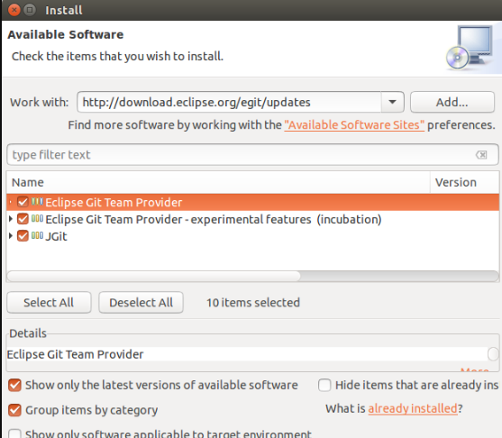

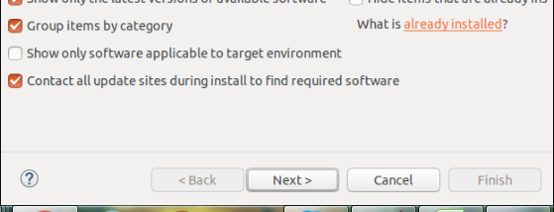

1. [Git user settings in Eclipse](http://www.vogella.com/tutorials/EclipseGit/article.html#git-user-settings-in-eclipse)

To use Git you must configure your full name and email address. This information is used to fill the author and committer information of commits you create. These Git configuration settings can be adjusted via the Eclipse preference setting. Select Window ▸ Preferences ▸ Team ▸ Git ▸ Configuration to see the current configuration and change email address and username.

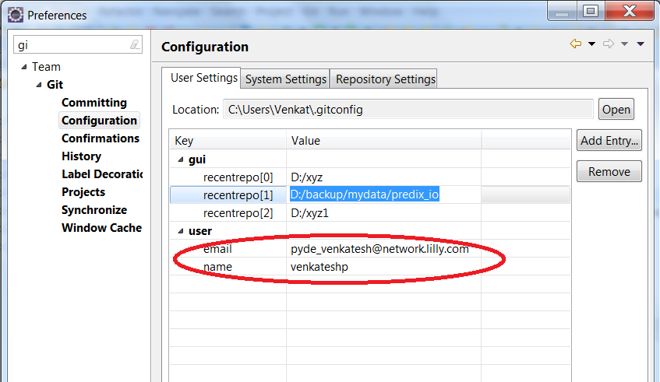

1. [Configuring the toolbar and the menu for Git usage](http://www.vogella.com/tutorials/EclipseGit/article.html#configuring-the-toolbar-and-the-menu-for-git-usage)

To simplify access to the common Git operations you can activate the Git toolbar. For this select Window ▸ Perspective ▸ Customize perspective…​ and check the *Git* and *Git Navigation Actions* entries in the *Action Set Availability*tab.

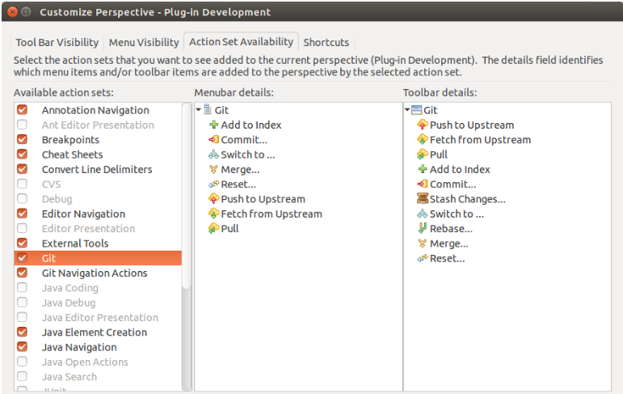



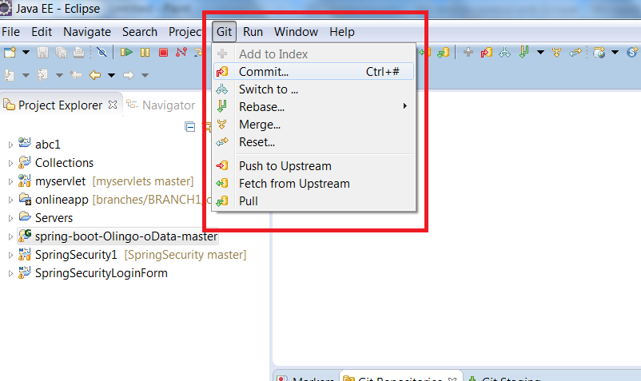

1. [Working with Eclipse projects in a Git repository](http://www.vogella.com/tutorials/EclipseGit/article.html#working-with-eclipse-projects-in-a-git-repository)

[4.1. Adding a new project to a local Git repository](http://www.vogella.com/tutorials/EclipseGit/article.html#adding-a-new-project-to-a-git-repository)

Create sample project and move it to git remote repository.

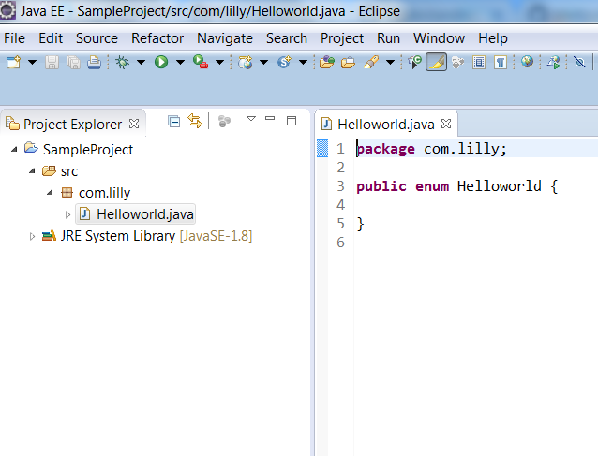

To move above project into GIT remote repository we need to follow below steps.

Step-1:

Right click on project -> Team -> Share project

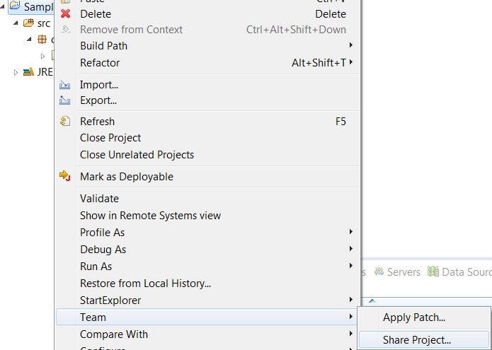

Step2:

Select GIT and click on Next button

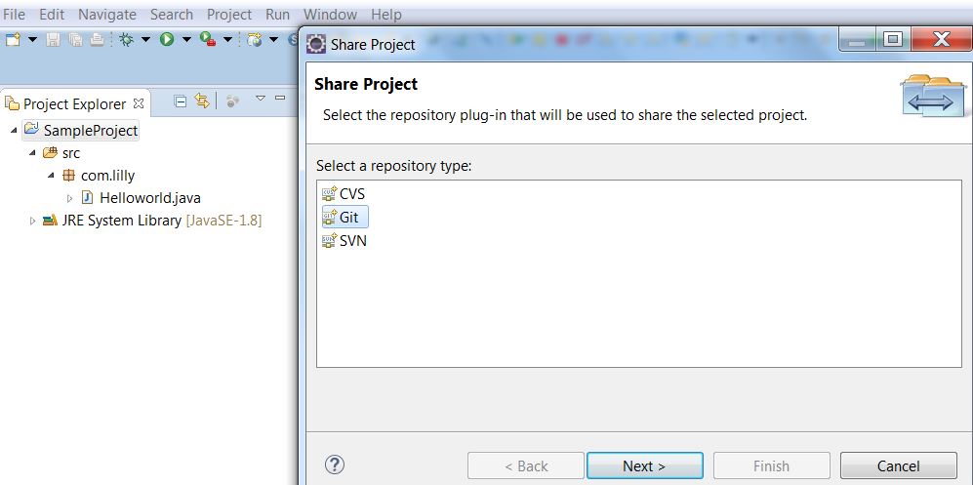

Step3:

Click on create button to provide local repository path.

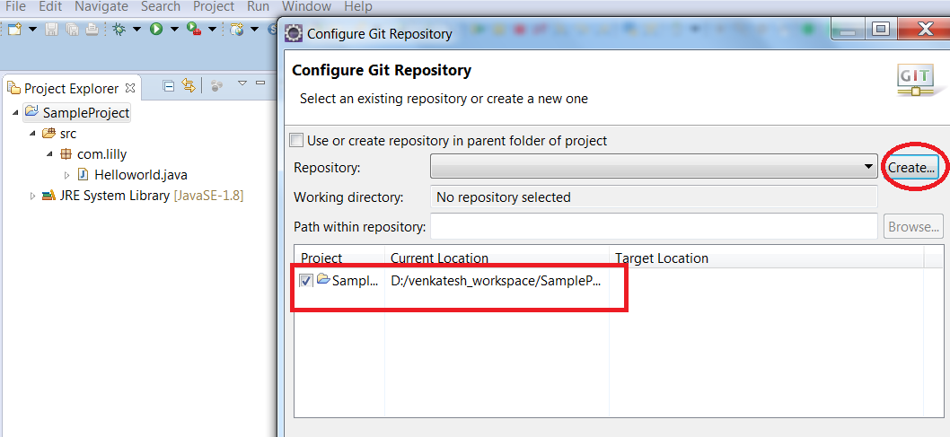

Step4:

Browse local repository location and click on finish.

Local repository can be any path in local system.

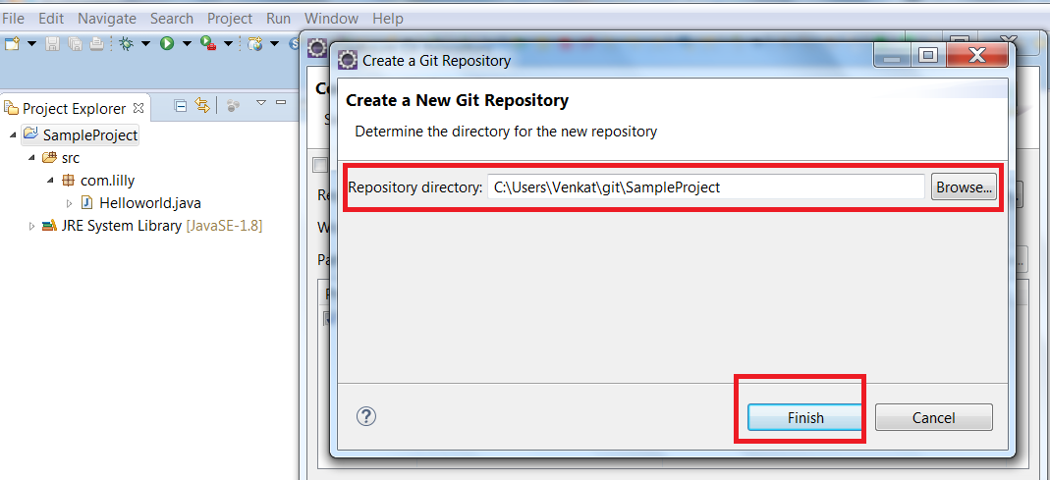

Step5:

Click on finish button to create local repository

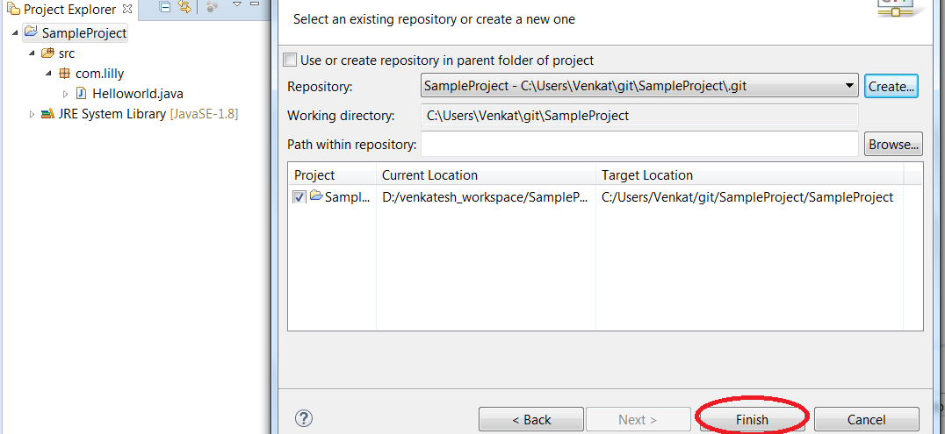

Step6:

Open git repositories to view the project in local repository.

*Windows -> show view -> other.. -> expand git -> select git repositories*

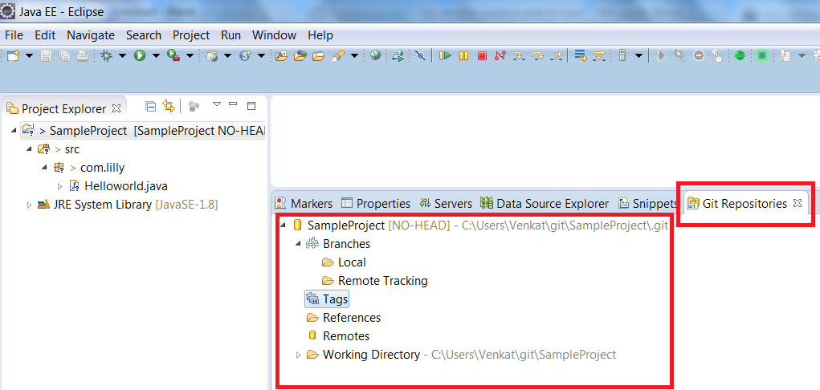

Step7:

Now move complete project from eclipse to local repository and to we need to follow

Below step.

Right click project -> Team -> Commit

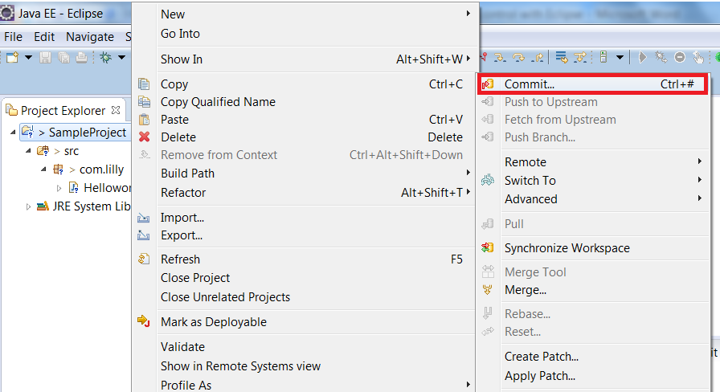

Select all files and enter proper comment and finally click on commit button.

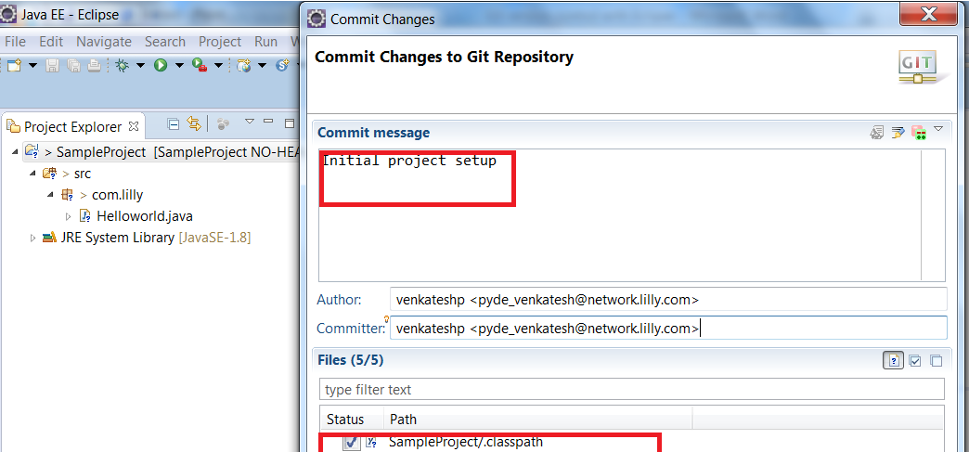

Now verify in Git repositories view for local repo project.

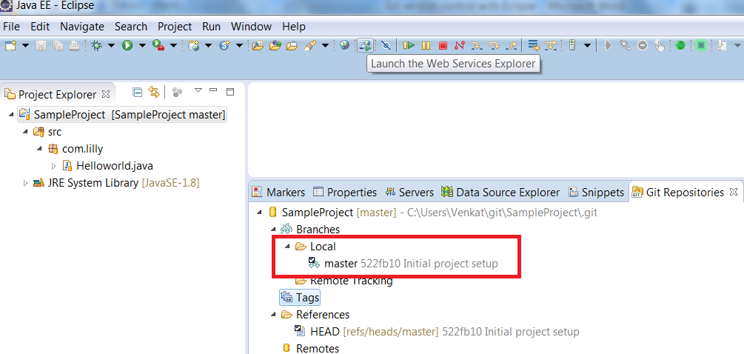

[4.2. Adding a new project to a remote Git repository](http://www.vogella.com/tutorials/EclipseGit/article.html#adding-a-new-project-to-a-git-repository)